**Advance DevOps lab**

**Experiment 5**

**Name: BALOCH MUZAMMIL HAFEEZ ROLL NO: 612012**

**Semester: V**

**Branch: Information Technology**

1. **What is AWS Lambda?**

Ans: AWS Lambda allows you to run code without having to provision or manage servers. You only pay for the compute time you use; there are no fees when your code is not running. With Lambda, you can run code for almost any form of application or backend service with no administration. Simply upload your code, and Lambda will handle everything needed to execute and grow it with high availability. You can configure your code to be triggered automatically by other AWS services, or you can call it directly from any web or mobile app.

1. **What is serverless computing?**

Ans: Serverless computing is a means of offering on-demand backend services. Users can use a serverless provider to build and deploy code without having to worry about the underlying infrastructure. Because the service is auto-scaling, a company that obtains backend services from a serverless vendor is charged depending on their calculations and does not have to reserve and pay for a fixed amount of bandwidth or number of servers. It should be noted that, despite the term, actual servers are still used, but developers are not required to be aware of them.

1. **What languages does AWS Lambda support?**

Ans: AWS Lambda natively supports Java, Go, PowerShell, Node.js, C#, Python, and Ruby code, as well as a Runtime API that allows you to write your functions in any other programming language. Please read our Node.js, Python, Java, Ruby, C#, Go, and PowerShell documentation.

1. **What is AWS DynamoDB Table**

Ans: Amazon DynamoDB is a fully managed NoSQL database service with seamless scaling and quick and predictable performance. DynamoDB offloads the administrative constraints of running and maintaining a distributed database, removing the need to worry about hardware provisioning, setup and configuration, replication, software patching, or cluster scaling. DynamoDB also supports encryption at rest, removing the operational load and complexity associated with protecting sensitive data. See DynamoDB encryption at rest for further details.

1. **Explain AWS IAM service**

Ans: AWS Identity and Access Management (IAM) is a web service that allows you to regulate access to AWS services in a secure manner. IAM is used to manage who is authenticated (signed in) and authorised (has access to resources).

When you create an AWS account, you start with a single sign-in identity that has full access to all of the account's AWS services and resources. This identity is known as the AWS account root user, and it may be accessed by logging in with the email address and password you used to create the account. We highly advise against using the root user for routine operations. Keep your root user credentials safe and use them solely for actions that only the root user can perform.

1. **To understand AWS Lambda, create your first Lambda functions using Python / Java / Nodejs. Create AWs Lambda function and configure a trigger for Amazon Simple Storage Service (Amazon S3). The trigger invokes your Lambda function every time that you add an object to your Amazon S3 bucket. Allow AWS Lambda to access Amazon DynamoDB Table .Create IAM role that allows full access to DynamoDB Table**

Step 1: Management Console Dashboard.

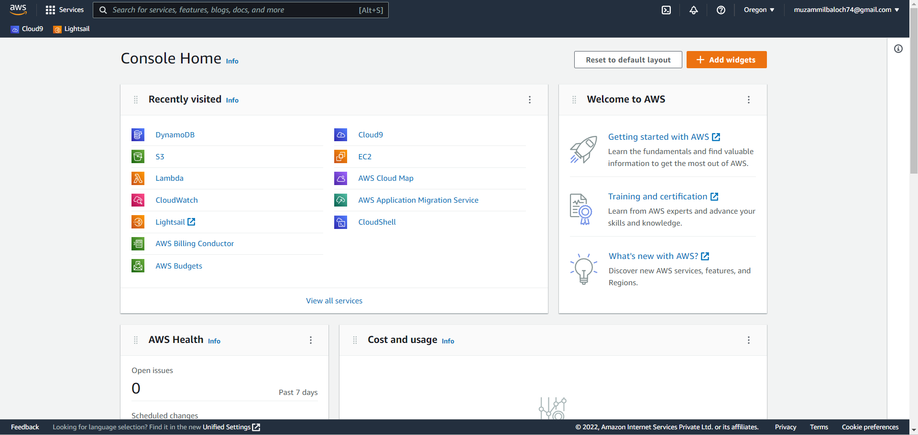

Step 2: In S3 create a bucket.

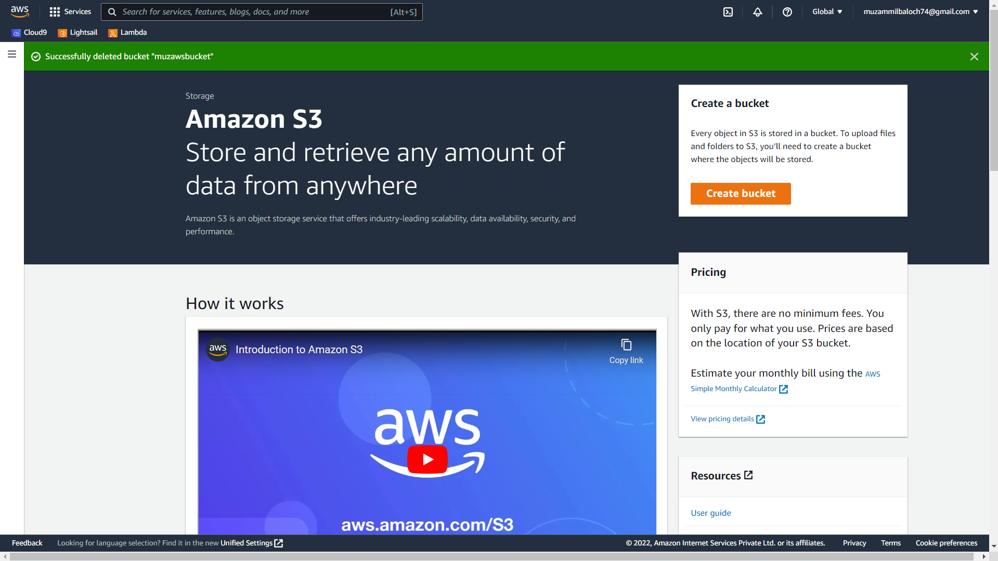

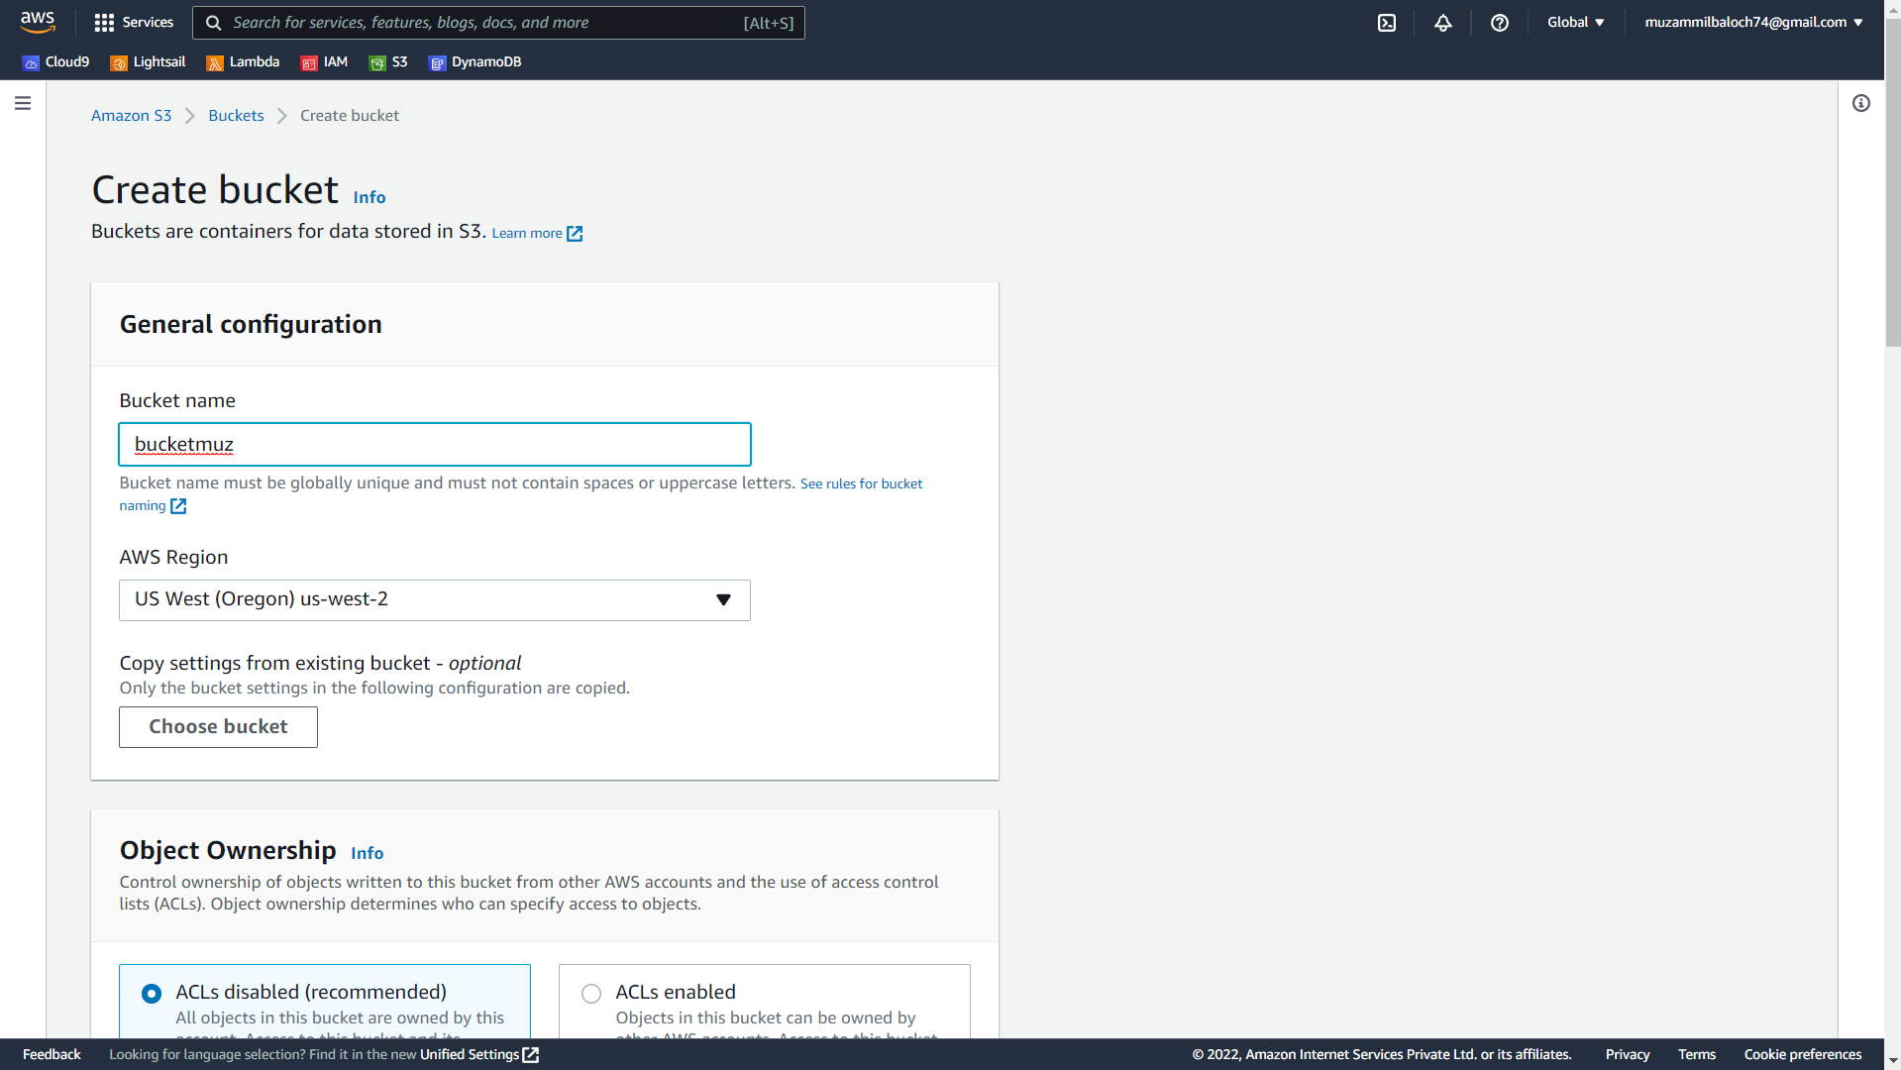

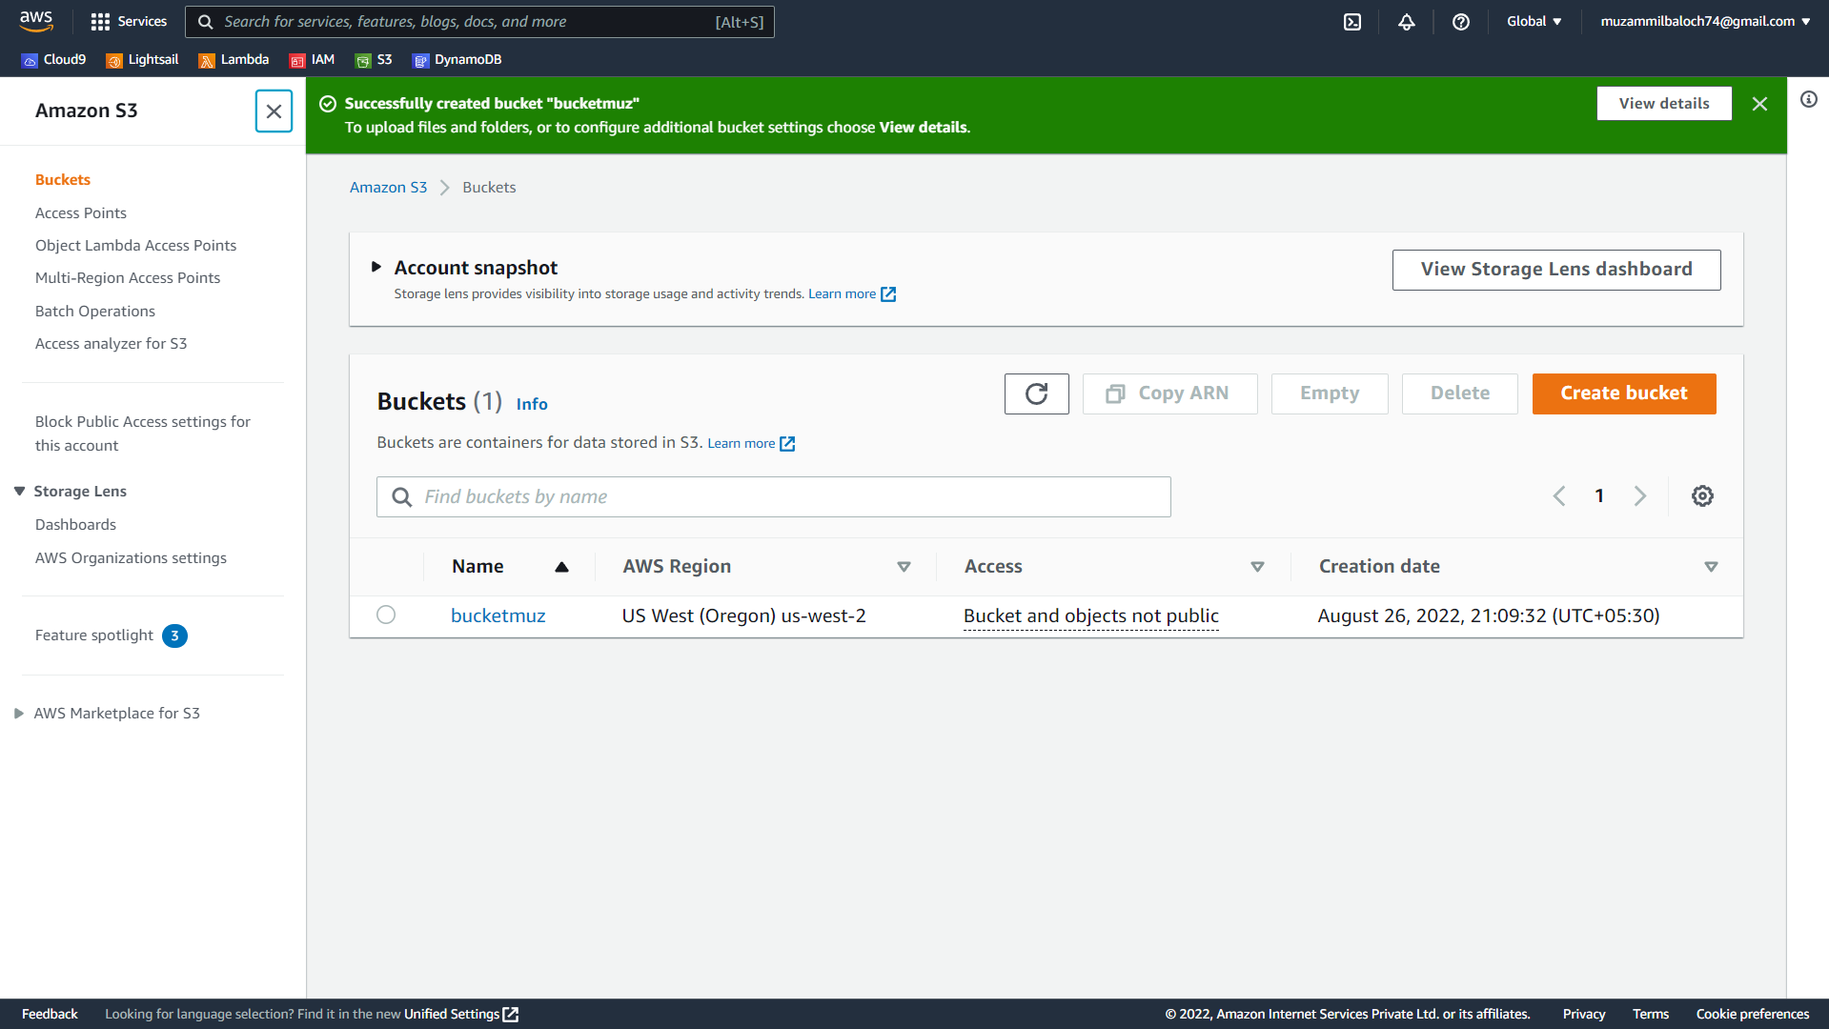

Step 3: In AWS services navigate to DynamoDB and create a table.

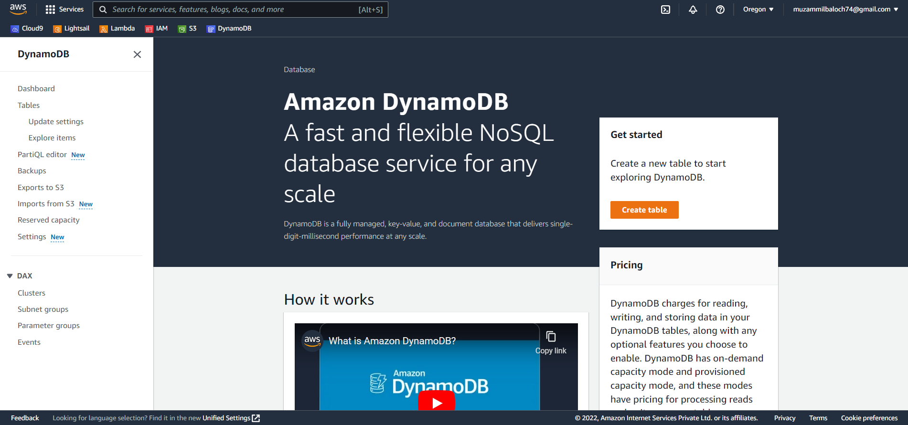

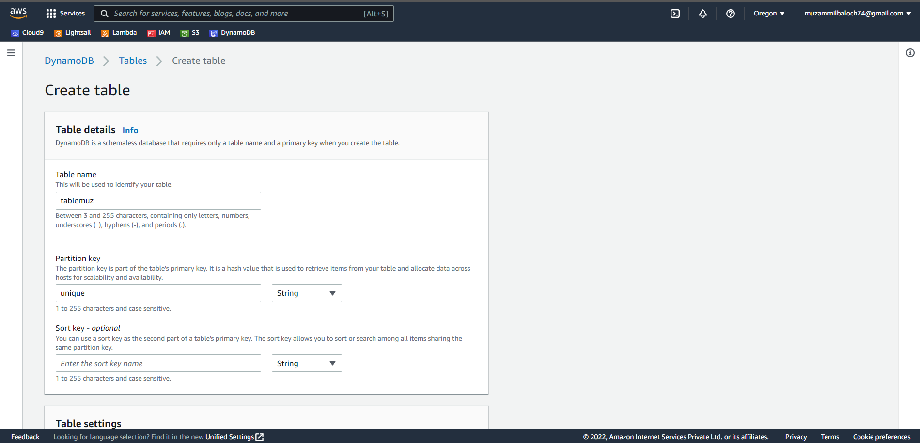

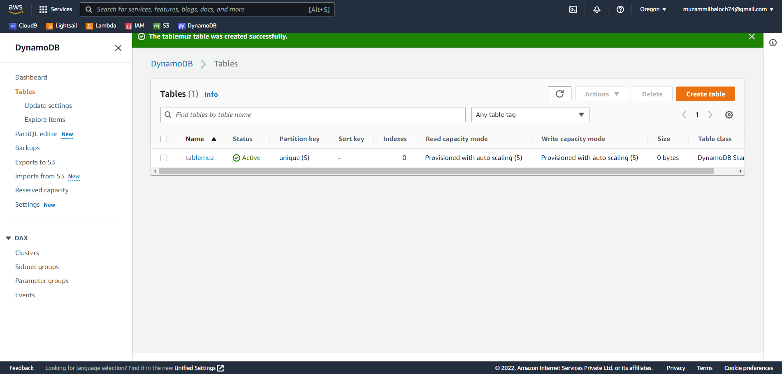

Step 4: In AWS services navigate to IAM and create a role with DynamoDB full access .

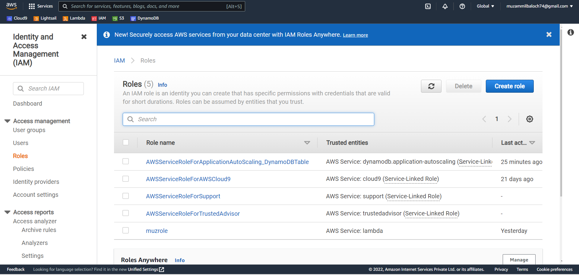

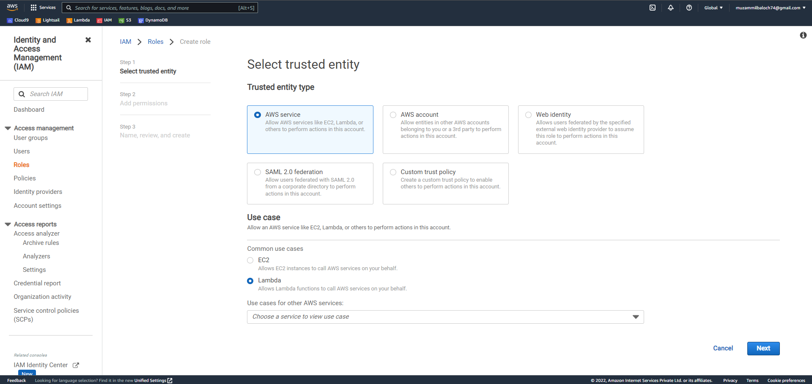

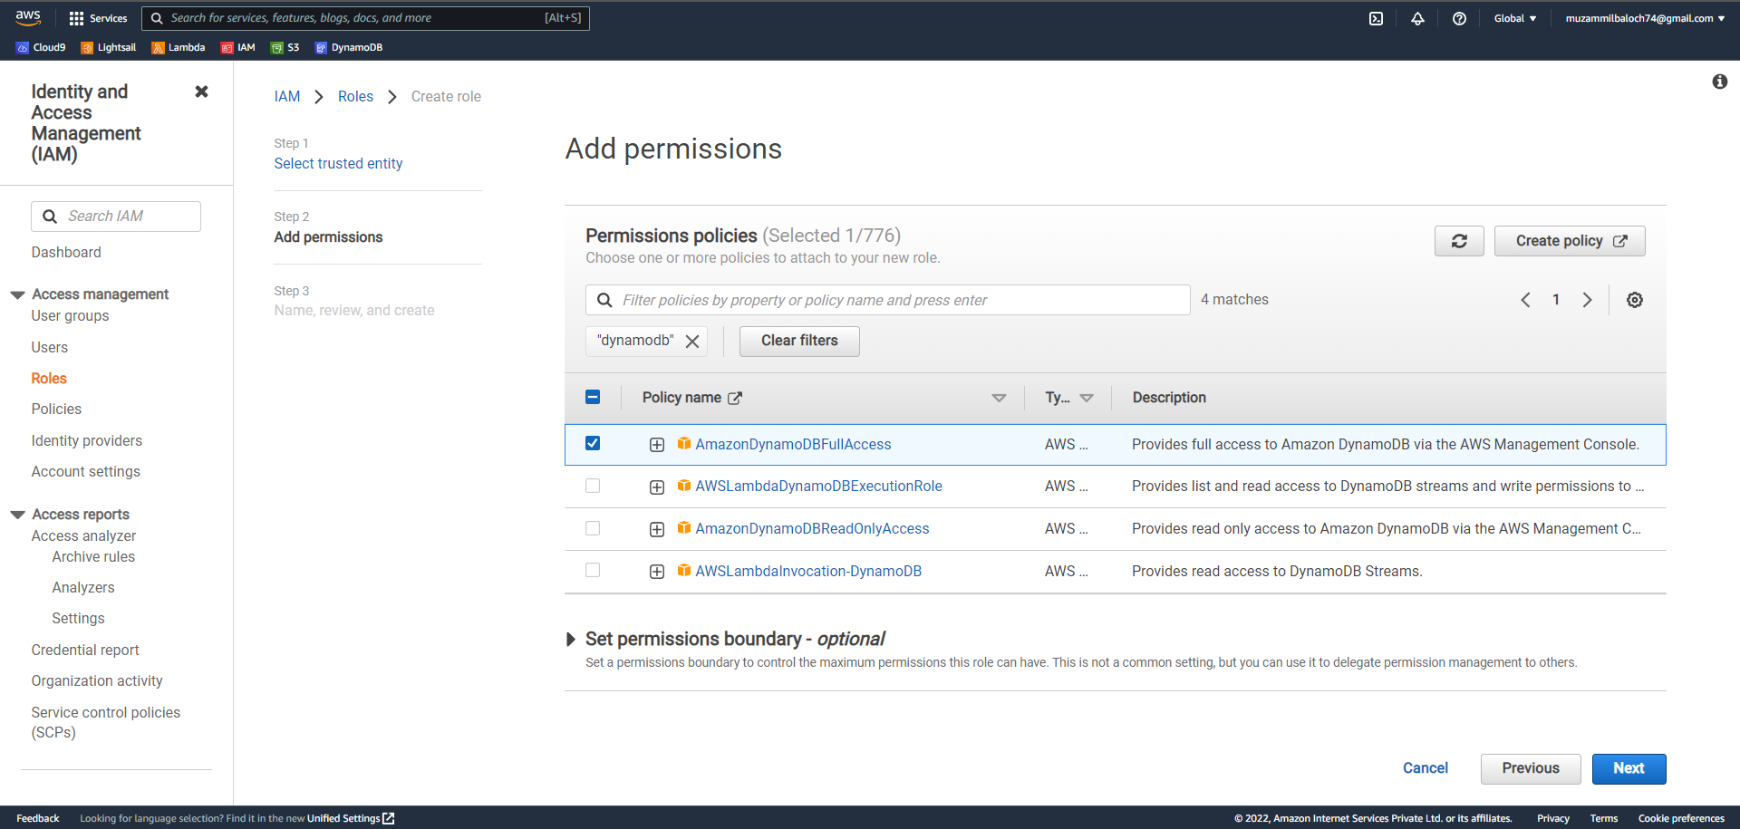0

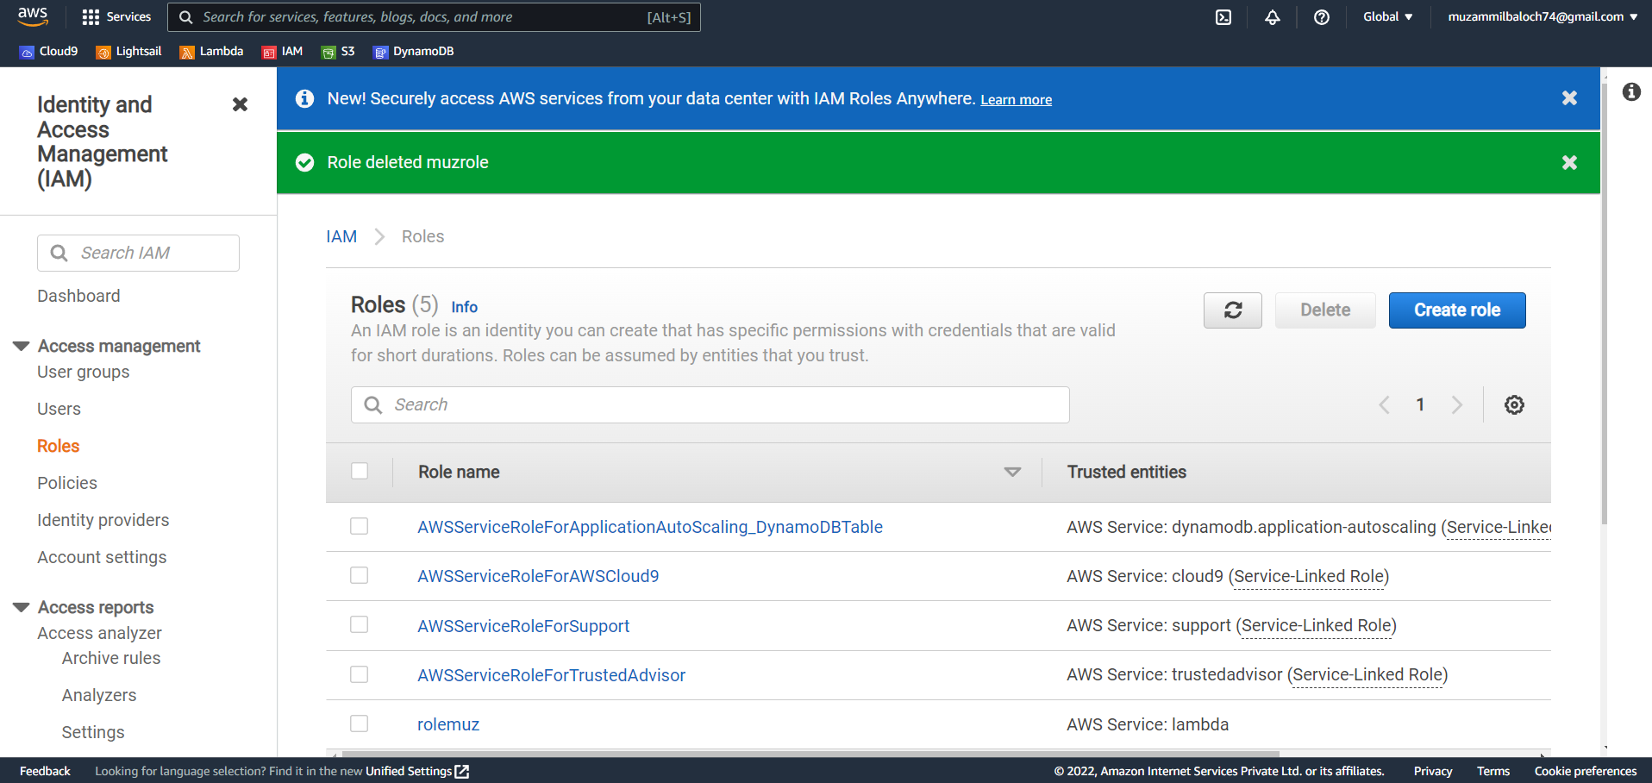

Step 5: In AWS services navigate to Lamda, create a function then assign role and trigger.

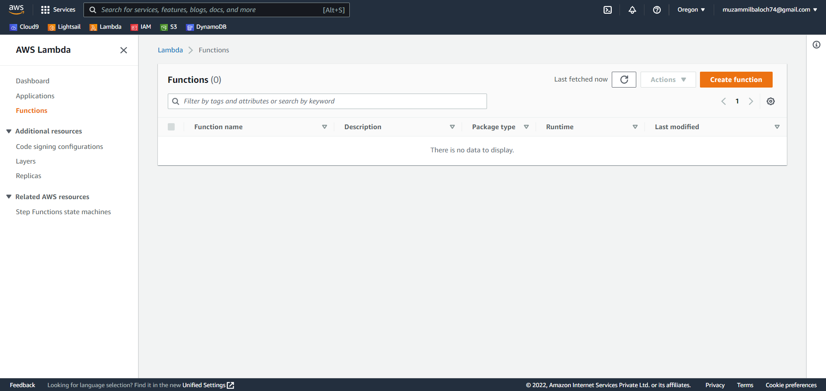

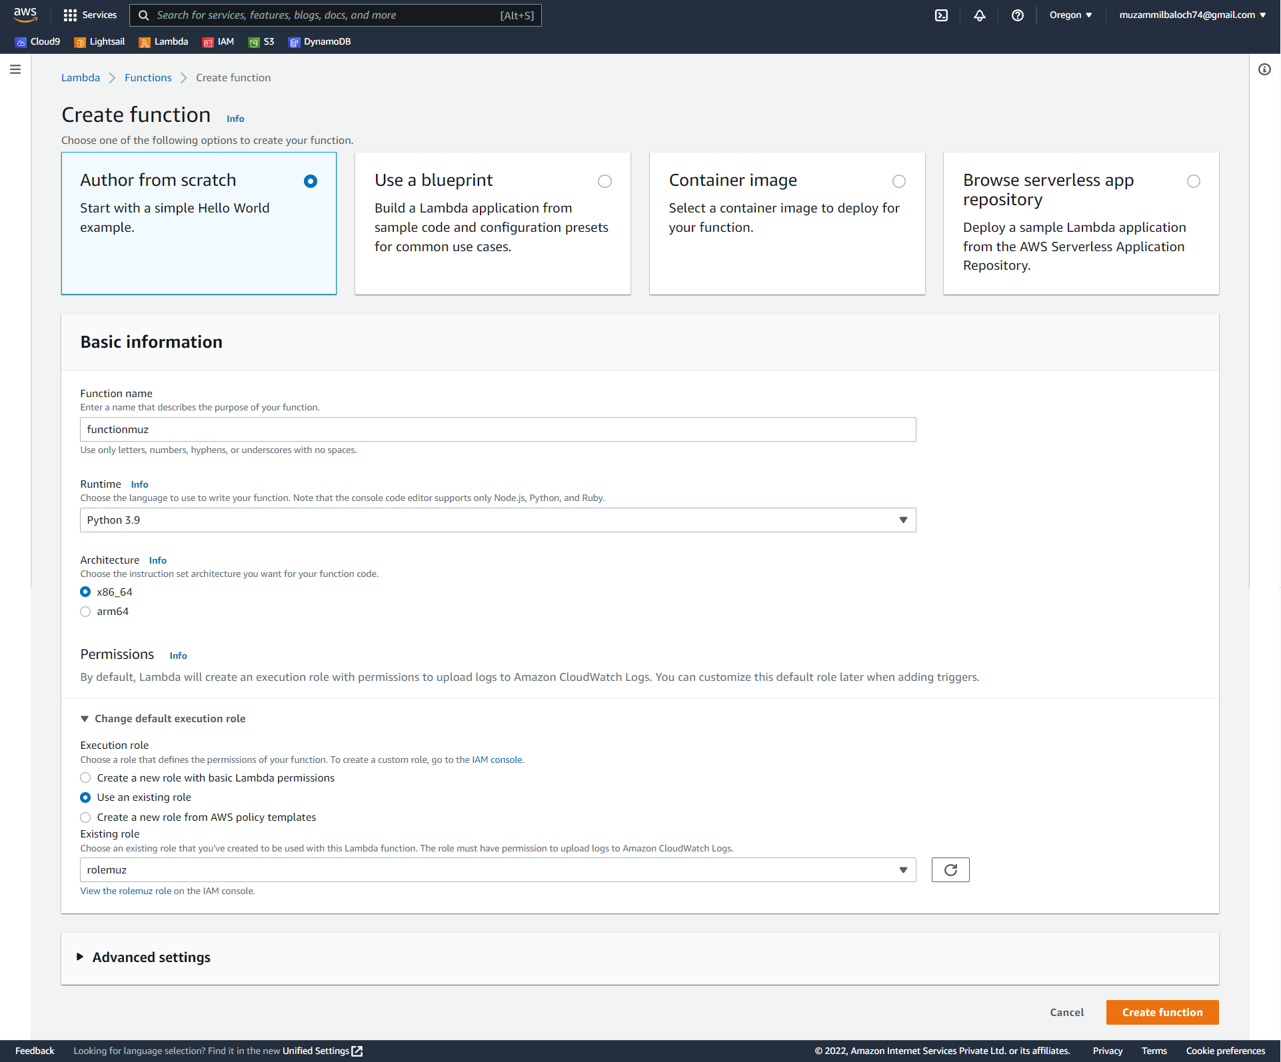

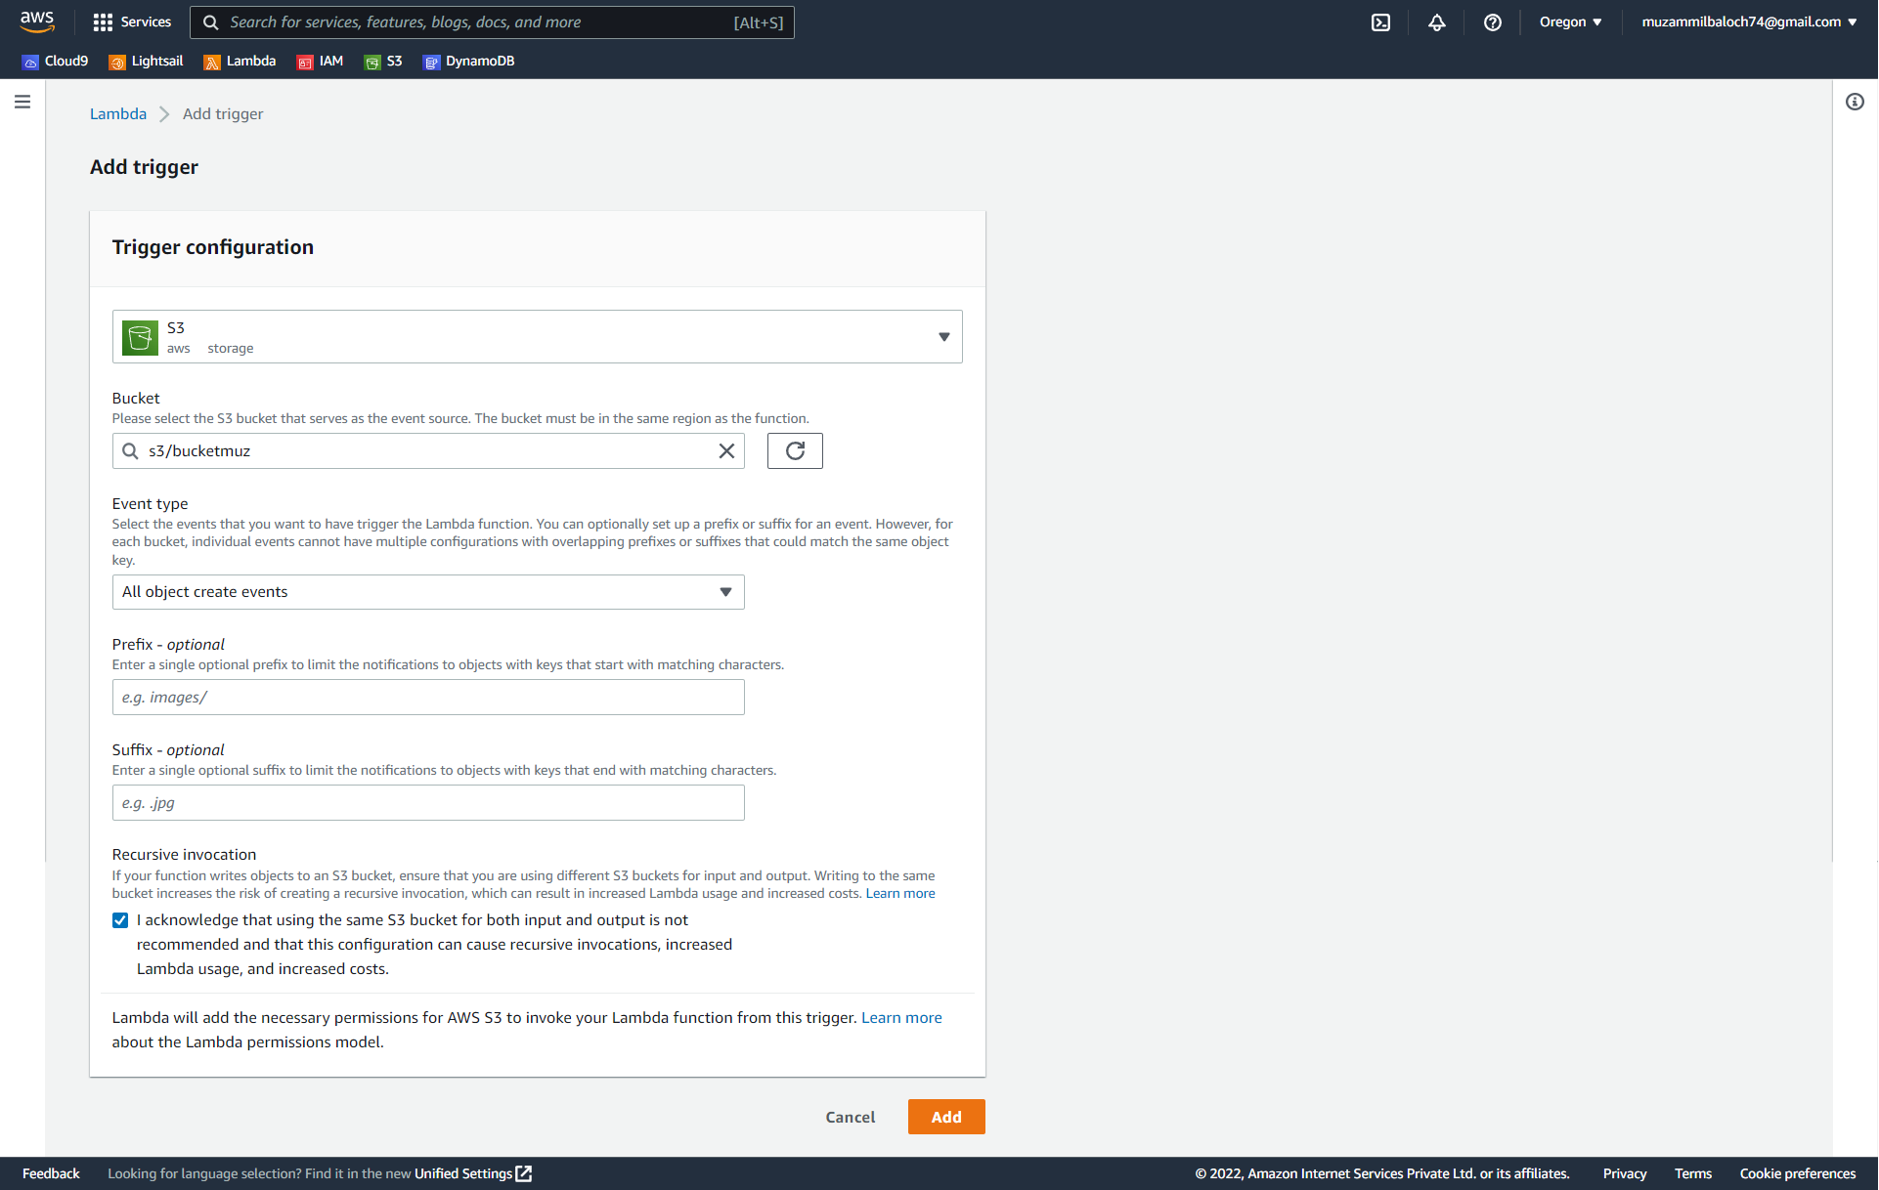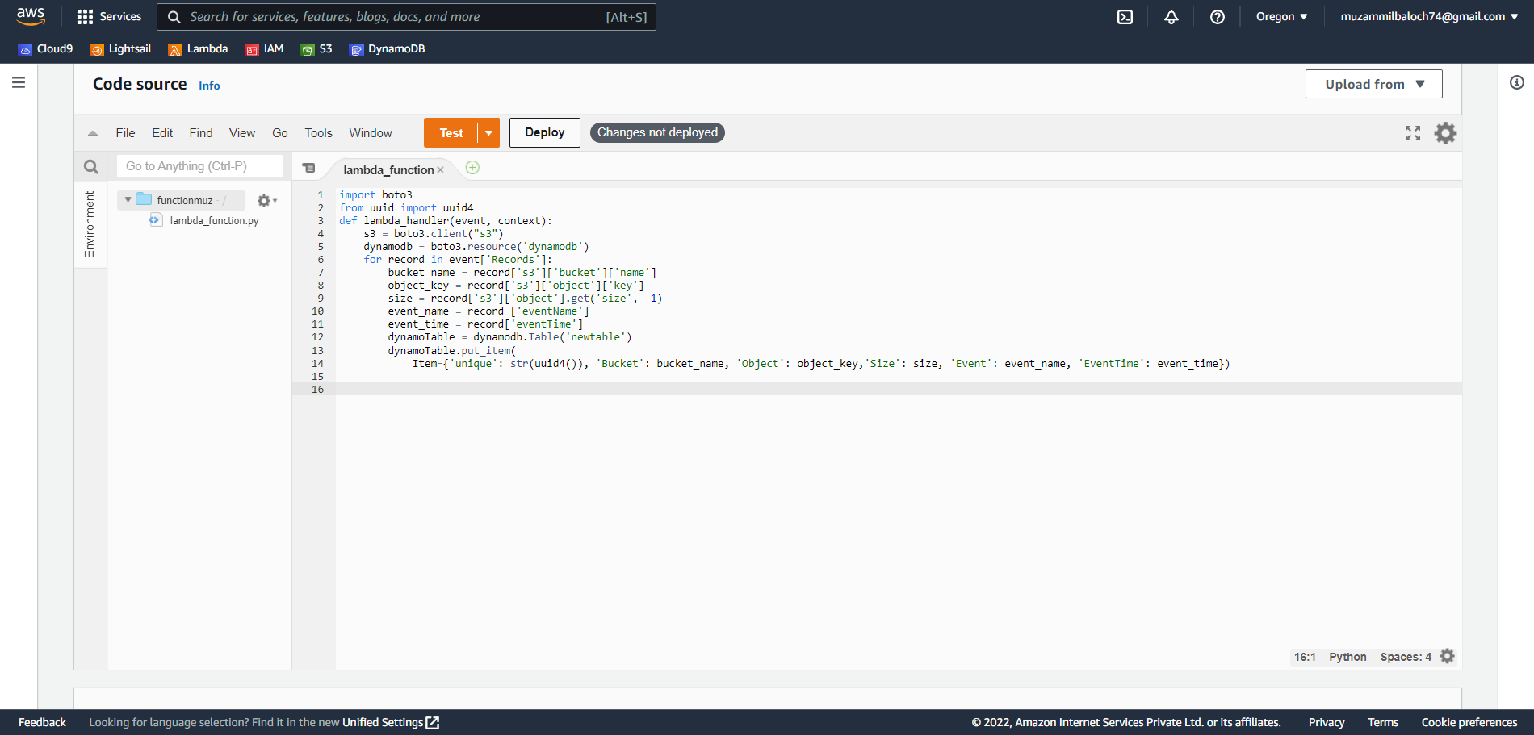

Step 6: Now, upload an object and check the table for an update.

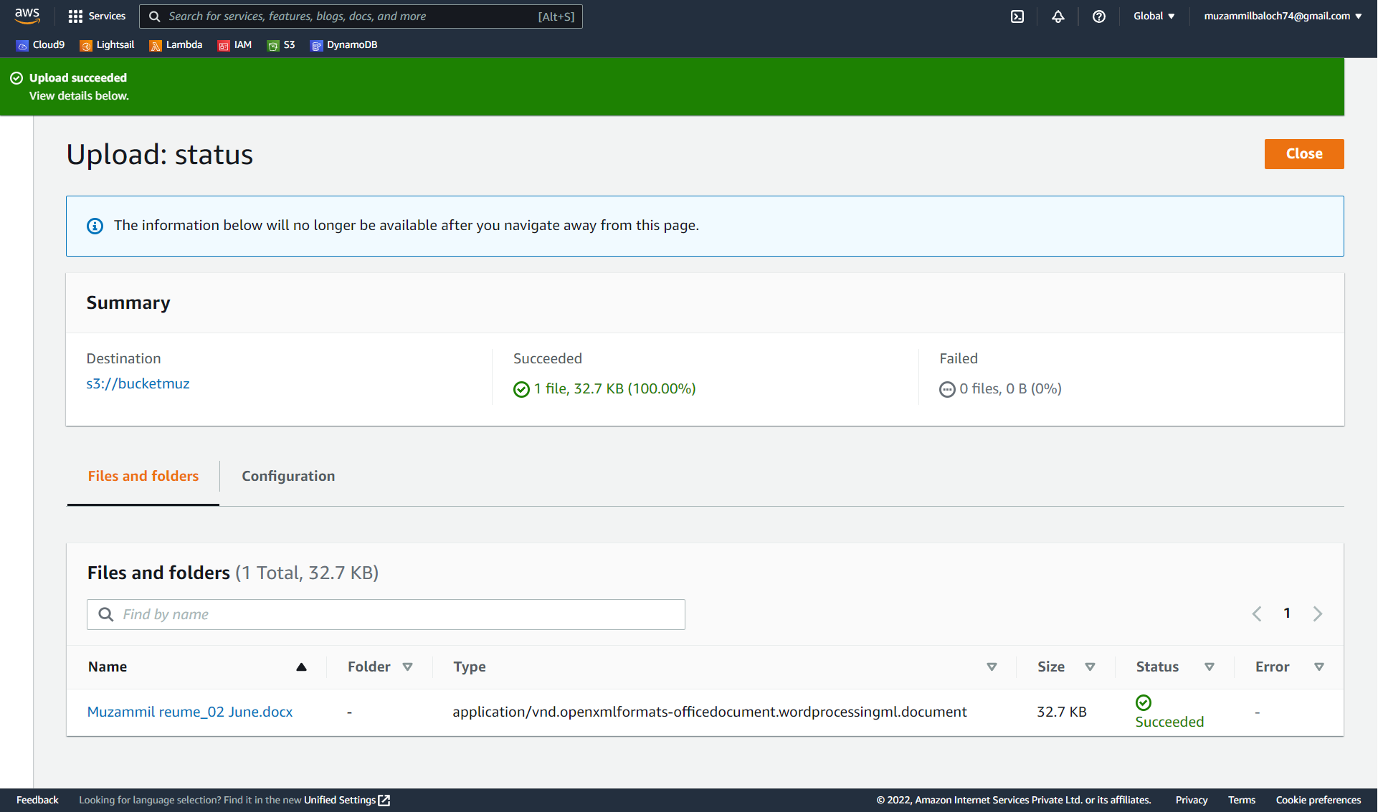

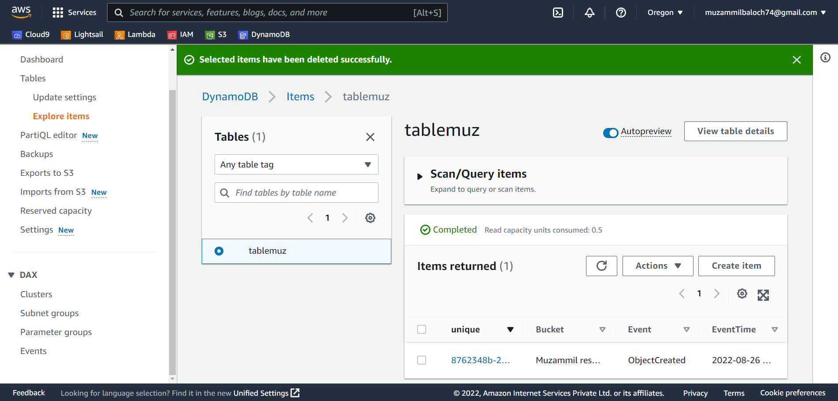

Step 7: Delete bucket,table,role and function.

